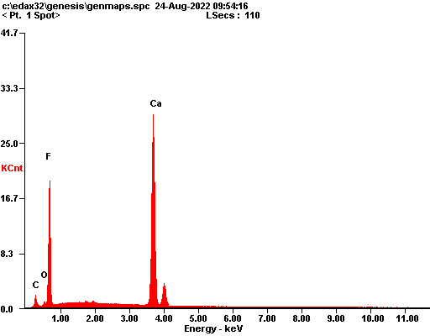

|  |  |  |
| --- | --- | --- |
| ***Element*** | ***Wt%*** | ***At%*** |
| ***CK*** | 02.98 | 06.36 |
| ***OK*** | 01.95 | 03.13 |
| ***FK*** | 41.82 | 56.45 |
| ***CaK*** | 53.25 | 34.07 |
| ***Matrix*** | Correction | ZAF |

